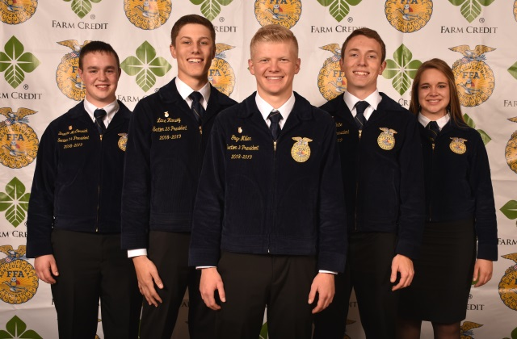
Pictured above (from L to R) in Photo 2019-2020 State Officers.jpg: Brodee McCormick, Reporter; Lane Harvey, Vice President; Gage Miller, President; Collin White, Secretary; Emma Freebairn, Treasurer
STATE OFFICER TEAM ELECTED AT ILLINOIS FFA CONVENTION
SPRINGFIELD –The 2019-2020 Illinois State Officer Team was elected Thursday, June 13, by delegates at the 91st annual Illinois State FFA Convention. The officers will be installed Thursday afternoon to serve the Illinois Association FFA for the next 12 months.
The newly elected officers are:
- President: Gage Miller, 18, of Cambridge (Henry County) and the Cambridge FFA Chapter. He is the son of Travis and Starla Fransene and Justin and Amy Miller and a 2019 graduate of Cambridge High School. “As a state officer, I will make it my goal to impact members throughout the state and ignite their passion for the FFA,” Miller says. “I’ll also use my passion for agriculture to advocate for the agricultural industry and work with other organizations to improve agricultural education in the state.”

- Vice President: Lane Harvey, 17, of Fairfield (Wayne County) and the Fairfield FFA Chapter. He is the son of Patrick and Jennifer Harvey and a 2019 graduate of Fairfield Community High School. “My daily objective is to work toward my ‘why’ and my purpose to be an encouragement and motivator to as many members as possible,” Harvey says. “I’ll put forth every effort to keep Illinois FFA one of the most impactful youth organizations in the state.”

- Reporter: Brodee McCormick, 18, of Athens (Menard County) and the Athens FFA Chapter. He is the son of Will Tomlinson and Mandy McCormick-Tomlinson and a 2019 graduate of Athens High School. “I’d like to continue the proud traditions of leadership development, personal growth, and career success in the FFA,” McCormick says. “As a state officer, I will use my time and talents to elevate and inspire members across the state.”

- Secretary: Collin White, 18, of Forest City (Mason County) and the Midwest Central FFA Chapter. He is the son of Eric and Jennifer White and a 2019 graduate of Midwest Central High School. “As a state officer, I will boost young members’ spirits and motivate them to be their best,” White says. “I want to give back to the organization that has helped me grow into a better person without fear and with memories that last a lifetime.”

- Treasurer: Emma Freebairn, 18, of Ottawa (LaSalle County) and the Serena FFA Chapter. She is the daughter of Scott and Heather Freebairn and a 2019 graduate of Serena High School. “I want to contribute to our members’ growth and leadership success by using the leadership skills FFA has taught me,” Freebairn says. “I’d like to leave a lasting impact and inspire them to dream big.”

The five officers were elected from a group of 10 candidates selected by a committee in early spring. Each officer puts their collegiate pursuits on hold for one year as they serve the Illinois Association FFA. Officers typically travel more than 20,000 miles visiting FFA chapters around the state, conducting workshops and meetings, representing Illinois FFA in professional settings, and promoting agricultural education. Since 1929, Illinois has elected a State FFA Officer Team.
“Elevate” was the theme of the three-day event which recognizes achievements of Illinois FFA members, elects the major state officer team, and celebrates agriculture. More than 5,000 FFA members, advisors and guests attended the June 11-13 event. Students at the convention were greeted with activities including a career fair featuring colleges and agribusinesses, an evening dance and talent show, and an opportunity to engage in the history of Illinois’ capital city.
The convention featured a new Spotlight on Service poster gallery where 24 FFA chapters highlighted a service project their members completed in the past year, celebrating the collective impact of Illinois FFA’s volunteer service. The program featured addresses by National FFA Southern Region Vice President Jordan Stowe of Alabama and from each of the retiring major state officers.
###

About Illinois Association FFA
The Illinois Association FFA is part of the National FFA Organization, formerly known as the Future Farmers of America. More than 19,046 students are enrolled in 346 different FFA chapters in the State of Illinois. FFA is a national youth organization of 669,989 student members with a mission of making a positive difference in the lives of students by developing their potential for premier leadership, personal growth, and career success through agricultural education. Visit www.illinoisffa.org for more information.

About the Illinois Foundation FFA
Illinois Foundation FFA engages individuals, industry, education, government, and foundations in securing funds to support quality agricultural education and FFA programs in Illinois, including providing awards at the State FFA Convention. To learn more and become involved, visit www.illinoisffafoundation.org.

For more information, contact:
Illinois FFA Center | 3221 Northfield Drive | Springfield, IL 62702
217-753-3328 | www.illinoisffa.org

