Illinois Community College
Agricultural Education

Database User Guide

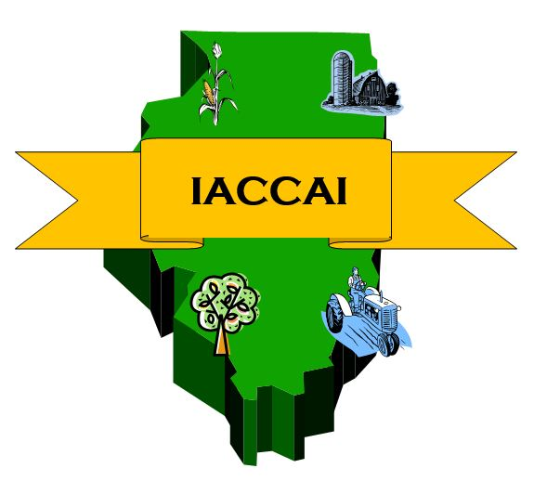
Illinois Community College Agricultural Education
Program Database Users’ Guide

The Illinois Association of Community College Agriculture Instructors (IACCAI) and Facilitating Coordination in Agricultural Education (FCAE) has developed a database to track Community College agriculture department enrollment, program characteristics, and employment data for their students and faculty members. In an effort to more accurately track students, plan for future employment needs, identify areas of improvement, and to provide data for marketing purposes, the IACCAI needs the help of your school. This guide will help you through the simple process of logging your school information into the database. Should you have any questions, please contact your local FCAE Program Advisor.

All AFNR faculty and support staff, both full- and part-time, should be added to this directory.
Data collection will end on June 30. All changes must be made (or forms completed and returned to FCAE Program Advisor) by June 30 at 5:00 PM. At that point all data will be summarized and distributed to each college at the Fall IACCAI Meeting.

Data to be entered is for the entire school year (all semesters from July 1-June 30)

Contents:
Part 1: Logging in to the database/faculty profile: Page 3
Part 2: School Information Page 4
Part 3: Degrees & Courses Information Page 6
Part 4: Blank Student Information worksheet/handout Page 9

Part 1: Logging in to the database, Teacher Profiles

First, log into the homepage www.ILAgEd.org. Select “Sign In” at the top right corner.

- You should receive an automated email from the system with your new login/password.
- If you forget your login information, click “forgot my password” and yours will be emailed to you. Password is case-sensitive.
- Your FCAE Program Advisor can provide you with an account login/password.

In the left menu of your Dashboard, select “Account Settings”
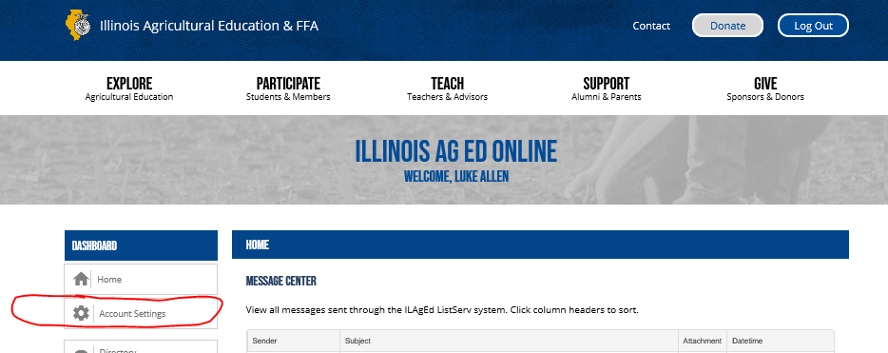
To update your teacher profile information:
  - Teacher Image: Upload a close-up photo for use in the Faculty/Staff Directory. This directory is available online to help faculty recognize other faculty members from around the state when contacting each other.
  - Focus Area: refers to the specific content area that the teacher works in.
Example: Horticulture, Landscape Design, Agri-Business, Mechanics.
  - Contact Hours: Enter the total contact hours you are responsible for THIS YEAR.
  - Education: For each degree earned, select the school the degree was received from and the year that the degree was completed.
Example: BS- Illinois State University, 1994
MS- University of Illinois, 1998
PhD- Ohio State University (choose “Out of State University”) 2005
  - Extra Duty Pay: Enter a row for each category of extra-duty pay (above your step position on the salary schedule) that you earn. If you earn a multiplier, please enter the equivalent gross dollar amount.
Example: Livestock Judging Coach, $3500
Student Advisement & Recruiting, $1500

  - Full Time Work Experience: List any full-time industry (work) experience you have.
Example: Landscape Architect, 11 years
Grain Merchandiser, 5 years

*Be sure to choose the “Save Changes” button on the bottom of the page before moving on.

Part 2: School Information
In the blue header of your Account Settings, choose “School Info”
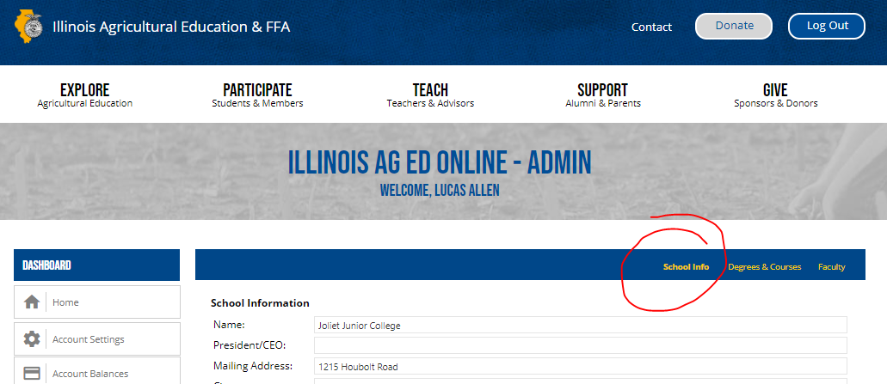
- Please use the first section of this page to enter college & department information.
- The bottom of the page seeks total enrollment numbers for your college. This can be obtained from your College Registrar.
            - Enrollment- enter the total number of students enrolled in the institution, both degree and non-degree students.
            - Full Time Equivalent: Enter your colleges’ Full Time Equivalent enrollment number. This can be obtained by your college administrative office. It represents one student taking 15 credit hours per semester
Example: Student taking 15 course hours= 1 FTE
Student taking 10 course hours= 2/3 FTE
Student taking 20 course hours= 1 1/3 FTE
- The minimum number of contact hours required per year for each fulltime faculty (Example: 24)
- The average contact hours of full-time Ag faculty members (Example: 9)
- The overload pay per contact hour, for school year hours. (Example: $50 per hour during the school year. Do not include summer overload pay)
- Enter the number of non-Ag degree seeking students taking courses in your department.
- Enter the number of Degree seeking students that were in a HS Ag classes.
- Enter the number of Degree seeking students that were FFA Members in HS.
- Enter the number of High School CDEs & Events hosted by your department.
- Enter the total gross income generated by student internships.
- Included in Ag Program section
    - If any of the following career pathways are offered at your institution, then check the appropriate box: Vet Tech, Diesel Tech, Horticulture, or Environmental Science.
    - Example: some schools include Environmental Science in the Ag department, while some schools teach it in the Science department. Diesel Tech may be taught in the Ag or Automotive/ Industrial Tech departments. Check the boxes that are programs your school offers, whether they are in the Ag department or not.

- Department Facilities
    - Check the appropriate boxes in this section if your program has facilities including: Greenhouse, Ag Mechanics Labs, Ag Computer Labs, Vet Tech Labs, Orchards, Nurseries, Land Labs, and Outdoor Soils Research Labs. Please also enter the scope of your facilities for each as appropriate.

- Advisory Committees
    - Enter any advisory committee information that your department utilizes. Include the number of meetings per year and the number of members on each committee.
    - Example: Horticulture Advisory, 2 Meetings/year, 12 members.
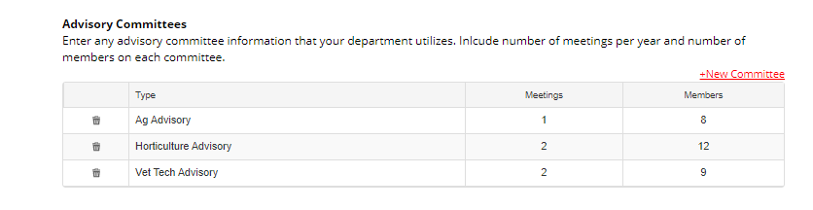
    - If you need to change info for a committee, just delete the row by clicking the garbage can at the beginning of the row and enter a new committee.

- Other Notes of Interest
    - Enter any additional information about your department and programs here. This information will be visible on the public view of your school profile.
    - Include any industry certifications that your department maintains
    - Example: 92% of graduates are placed in full time employment; Department is certified by the National Association of Landscape Professionals.

*Be sure that you choose the “Save Changes” button on the bottom before moving on.

Once this information is up to date, click “Degrees & Courses” in the top blue menu to proceed to the next step.

Part 3: Degrees & Courses

Enter enrollment information for each Degree your institution offers. To add a new degree, click “+ New Degree” in the top right of each degree area.

We used to ask for farm/nonfarm numbers for both genders. Now, just enter the total enrollment for each gender in each major, then enter the total students who identify as farm students (their family income is greater than 50% derived from production agriculture).

Internships and Internship Hours: These are the numbers required to obtain a degree in that area- it is NOT the number of students doing internships in that area. Please report how many internships and total hours of internships required for a student to complete that degree area, usually listed in your school course catalog.
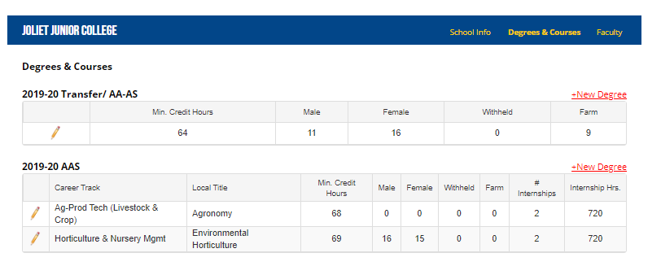
- AA or AS (Transfer) Section:
    - Enter Minimum Credit hours (number of hours required for the degree), number of male/female/gender withheld students, then enter number of students from farm background (family primary source of income is production ag), the number of internships required for each student who completes the degree (usually 0), and the total number of hours required from each internship (not the total number of internships by all students in the program).

- AAS in Applied Science:

    - First, choose the ICCB Category Title that each of your degrees falls into.
    - Enter the local title of each AAS Degree that you offer.
    - Enter Minimum Credit hours (number of hours required for the degree), number of male/female/gender withheld students, then enter number of students from farm background (family primary source of income is production ag), the number of internships required for each student who completes the degree (usually 1,2, or 3), and the total number of hours required from each internship, not the total number of internships by all students in the program.
    - Should you need to add more lines for more degrees, enter the number that you need to add in the text box below the AAS Categories and choose the “+ New Degree” button.

- Certificate Degree Programs:
    - First, choose the ICCB Category Title that each of your certificates fall into.
    - Enter the local title of each Certificate that you offer.
    - Enter Minimum Credit hours (number of hours required for the degree), number of male/female/gender withheld students, then enter number of students from farm background (family primary source of income is production ag), the number of internships required for each student who completes the certificate (usually 1,2,3, or 4), and the total number of hours required from each internship- not the total number of internships by all students in the program.
    - Should you need to add more lines for more certificates, enter the number that you need to add in the text box below the AAS Categories and choose “+ New Degree” button.

Non-Traditional Course Delivery:
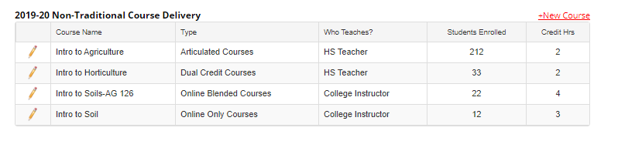
All nontraditional course delivery methods are now reported together in the same area.

- Articulated Courses
    - List all courses that offer Dual Credit to High Schools.
    - Include in the name who teaches the course. Enter either College or HS teacher: example, [Intro to Horticulture, High School Teachers]
    - Enter total students receiving credit in current School Year (July 1-June 30)
    - Enter # of Credit hours of each course (is the course a 2-credit hour class?)

- Dual Credit Courses
    - List all courses that offer Dual Credit to High Schools. If multiple schools offer the same dual credit course, just list it once, and list the total # students enrolled.
    - Enter total students receiving credit in current School Year (July 1-June 30)
    - Enter # of Credit hours of each course (is the course a 2-credit hour class?)
- Online Blended
    - Enter any courses that are offered through a hybrid online/traditional delivery system.
    - Each institution may have slightly different course designs in this section, but example would be lecture is online and labs are “in-person”
    - Example: Intro to Horticulture 103, 24 students enrolled, earns 3 credit hours.

- Online Only Courses
    - Enter any courses that are offered through a 100% online delivery system. Do NOT include courses that are blended online courses here.
    - Should you need to add more lines for courses, enter the number that you need to add in the text box below the courses and choose the “Add Now” button.
    - Example: Ag Economics 103, 12 students enrolled, earns 3 credit hours.

Data on this page is automatically saved each time you make an entry.

Student Information Worksheet

Please complete the following information for our records.

Name - _________________________ E-mail -________________________________

Address - _______________________________________________________________

Phone # - _______________ Gender: Male ___ Female ___ Other/Withheld ___

Degree option (pick one)
_____ Transfer Planned 4 year University - ____________________
Planned major - ___________________________
_____ Ag Mechanics
_____ Ag Production
_____ Ag Business
_____ Horticulture/Nursery
_____ Natural Resources/ Environmental Science
_____ Vet Tech
_____ Non-Degree student or enrolled in non-Ag degree

I am interested in joining PAS: yes____ no____ Collegiate Farm Bureau: Y __ N__

High School Attended - _______________________ City/State: __________________________

Year of graduation - __________

Previous work experience related to degree area: ______________________________
______________________________________________________________________

Years of HS Agriculture classes - __________ # Years of FFA membership - _________
(or not a member? Write N/A)
SAE in HS Ag Class- ____________________

Awards/Recognitions in High School or Work related
- _________________________________________________
- _________________________________________________
- _________________________________________________
Scholarships received: _____________________________________________________
Residence (pick one)
___ Non-Farm (family income is NOT derived from farming)

___ Farm (At least 50% of family income is derived from farming)

