Student Information Sheet Name_____________________________ Projected Graduation Yr:___________ Address__________________________________________________________________________ Home phone__________________ Cell Phone________________ Birthdate___________________ E-Mail ____________________________________ Father’s Name_______________________ Occupation_____________ Cell #__________________ Father’s E-Mail: ____________________________ Work #: __________________________ Mother’s Name_______________________ Occupation____________ Cell # _________________ Mother’s E-Mail: ____________________________ Work #: _________________________ In case of emergency, Contact:_____________________ phone_____________ Family Doctor___________________________________ phone_____________ Allergies: ________________________________________________________________________
1. Please list the courses you are enrolled in this year

HR | Class- 1st Semester | Teacher | Class- 2nd Semester | Teacher
1.
2.
3.
4.
5.
6.
7.
8.

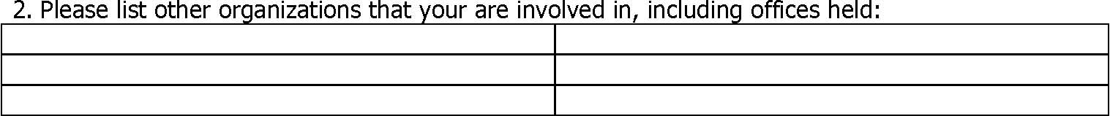

3. Please list FFA Activities that your are interested in participating in:

Page 2- Student information sheet

4. Please describe your plans for an SAE Program

5. List any “Agricultural/Horticultural” Experiences that you have had.

6. If you are currently employed, please provide the following information Employer: Supervisor (if different) Address: Phone:

7. What goals do you hope to achieve while in High School?

8. What are your career goals?

9. Please give directions to your home so that the Agriculture Teacher can conduct SAE Visits. Draw a map if helpful.

